Dishes and their allergen content – James Calvert Spence College

Dishes | 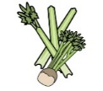 | 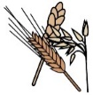 | 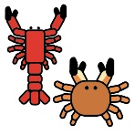 | 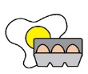 |  | 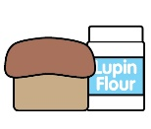 | 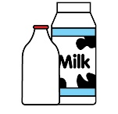 |  | 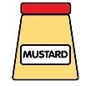 | 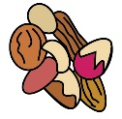 | 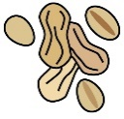 | 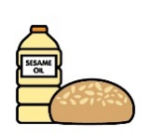 |  | 
Grab & Go | Celery | Cereals containing gluten* | Crustaceans | Eggs | Fish | Lupin | Milk | Mollusc | Mustard | Nuts† | Peanuts | Sesame seeds | Soya | Sulphur Dioxide
Bread - Roll |  | Contains |  |  |  |  |  |  |  | May Contain | May contain | May contain | Contains
Bread - Panini |  |  |  |  | See Label
Bread – Pizza Slice |  | Contains
Bread - Baguettes |  | Contains |  |  |  |  |  |  |  |  |  | May contain
Bread – Tortilla Wrap |  | Contains
Bread - Mini Stottie |  | Contains
Bread – Pioneer sliced white |  | Contains
Pasta |  | Contains
Pasta with Tomato sauce |  | Contains
Jacket Potato |  |  |  |  |  |  | Contains- with butter
Salad
Coleslaw | Contains | Contains |  |  |  |  |  |  | Contains
Sausage Roll |  | Contains |  | Contains |  |  | May contain |  | May Contain
Wedges Pot |  |  |  |  |  |  |  |  |  |  |  |  |  | May contain
Noodles- Curry Sauce/sweet chilli |  | Contains |  | Contains |  |  | May contain |  | May contain |  |  | May contain | May contain

