Dishes and their allergen content – James Calvert Spence College

Dishes | 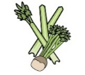 | 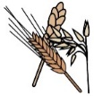 | 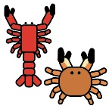 | 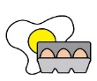 |  | 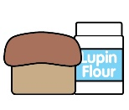 | 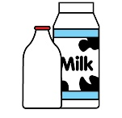 |  | 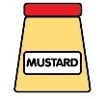 | 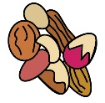 | 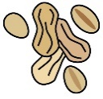 | 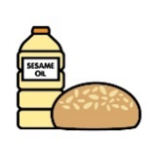 |  | 
Fillings | Celery | Cereals containing gluten* | Crustaceans | Eggs | Fish | Lupin | Milk | Mollusc | Mustard | Nuts† | Peanuts | Sesame seeds | Soya | Sulphur Dioxide
Cheese / cheese Salad | ✓ |  |  |  |  |  | Contains
Cheese Savoury |  |  |  | Contains |  |  | Contains |  | Contains
Chicken Tikka |  | Contains |  | Contains |  |  | Contains
BBQ Chicken | May Contain | Contains |  | May Contain |  |  | May Contain |  | May Contain |  |  |  | May Contain | Contains
Chicken Mayo & Bacon |  | Contains |  |  |  |  |  |  | Contains
Chicken Mayo |  | Contains |  |  |  |  |  |  | Contains
Chicken Fajita |  | Contains |  |  |  |  | Contains
Sliced Chicken
Honey Chilli Chicken | in | May Contain |  |  |  |  | May Contain |  |  |  |  | May Contain | May Contain
Italian Chicken
Tuna Mayo |  |  |  | Contains | Contains |  |  |  | Contains
Ham / Ham Salad |  |  |  |  |  |  | Contains
Egg Mayo |  |  |  | Contains |  |  |  |  | Contains
BLT |  |  |  | Contains |  |  |  |  | Contains

