Dishes and their allergen content – James Calvert Spence College

Dishes | 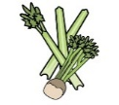 | 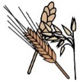 | 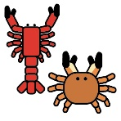 | 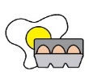 |  | 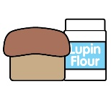 | 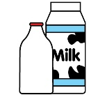 |  | 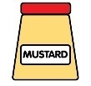 | 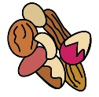 | 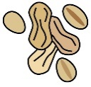 | 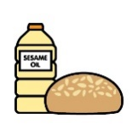 |  | 
Break | Celery | Cereals containing gluten* | Crustaceans | Eggs | Fish | Lupin | Milk | Mollusc | Mustard | Nuts† | Peanuts | Sesame seeds | Soya | Sulphur Dioxide
Pizzini |  | Contains |  |  |  |  | Contains
Belgium Waffles |  | Contains |  | Contains |  |  | Contains
Bread Roll (may contain sesame) |  | Contains |  | May contain |  |  |  |  |  |  |  | May contain
Croissants |  | Contains |  | Contains |  |  | Contains |  |  | May contain |  |  | May Contain
Cheese on Toast |  | Contains |  |  |  |  | Contains
Bagels |  | Contains |  |  |  |  |  |  |  |  |  | May Contain
Bacon Sandwich |  | Contains |  | Contains |  |  | Contains |  |  | May contain | May Contain | May Contain | Contains
Sausage Sandwich |  | Contains |  | Contains |  |  | Contains |  |  | May contain | May Contain | May Contain | Contains
Panini |  |  |  | See Label
Pizza Slice |  | Contains |  |  |  |  | Contains
Sandwiches |  |  |  | See Label
Yoghurt |  |  |  | See Label
Fruit Pots
Hash Browns |  | May Contain |  | May Contain |  |  | May Contain

