Writing a talk/speech – exam tasks:
You have been asked to give a talk to your class with the title:
The person I’d most like to spend a day with.
Your talk could be about a person who is famous such as a sportsperson, musician, inventor or national figure, someone from the past or someone who is not necessarily well known but who you admire.
Write what you would say in your talk. [20]
You are asked to give a talk to people in your class about your ambitions and what you hope to achieve in the next 10 years.
Write what you would say in your talk. [20]
Students often complain about being bored and having nothing to do through the long school summer holidays.
You have been asked to give a talk to you class giving your views, with suggestions and recommendations for making the most of school holidays.
Write what you would say. [20]
Many older people do not use modern technology because they do not understand it and are perhaps afraid of it.
You have been asked to give a talk to older people encouraging them to make use of modern technology.
Your talk should include one or more of the following:
- the internet
- social media such as Facebook and Twitter
- smart phones/smart watches
- tablets
Write what you would say. [20]

Planning your content:
Before you begin, read the task carefully. It is really helpful if you plan what you want to cover. 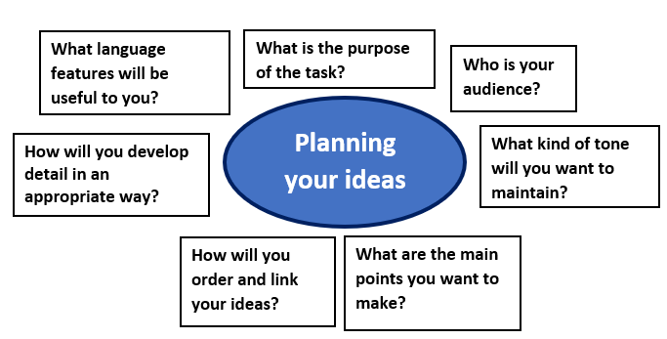
Structuring a talk/speech:
1. When writing a speech your content needs to be set out as a good piece of writing – make sure you use paragraphs and careful sentence structure.
2. You may wish to introduce yourself and you certainly need to introduce the content of your talk.
3. Include at least two or three main paragraphs in which develop the main points of your talk.
4. Link your ideas as you move between paragraphs so that the content of your talk is fluent.
5. Conclude with a clear focus on the task and audience.
Next steps…

Work through the PowerPoint that accompanies this resource.

Read or watch famous speeches from history. Are there any techniques that you can copy?

Work through some sample tasks and write a plan for them.

Read your teacher’s feedback for talks/speeches you have written in the past. What do they think you need to do to improve?

TOP TIPS:
- Try to develop your ideas thoughtfully – think about what will appeal to an audience.
- Link ideas across paragraphs to create fluent writing – you might repeat ideas to reinforce a point.
- Keep checking the task you have been given to make sure you remain focused.
- Choose persuasive techniques that help you and improve your writing – you don’t need to tick off every technique that you know.
Techniques to use:

A good talk/speech will be audience-aware, coherent and convincing.

Think about:

- vocabulary
use words that are specific and help you make your points
- organisation
you must write in paragraphs but make sure that these are organised in a logical way
- accuracy
punctuation is crucial to show how you can pace your talk and appeal to an audience
- persuasive techniques
you will have learned lots of these at school but give careful consideration to which ones will be useful for the task set
- tone
this will vary depending on your
task – e.g. for some audiences a
lively tone and the use of humour
may be useful
Definition:
A talk (or speech) is exactly what you would say if you were delivering a speech. You need to write as though your content will be listened to.
The audience and purpose of a speech can vary so understanding the task is crucial. This will help you decide on content and tone.
What is being tested?
- How you appeal to a reader, the quality of your ideas and how well you present them.
- Your ability to use sentencing, grammar and vocabulary.

Writing a talk/speech

Examples of past synthesis questions:
The following questions all had the following introduction:
To answer the following questions, you must use both texts.
Using information from both texts, explain briefly in your own words what happened when news of the mining accidents became known. [4]
Using information from both texts, explain briefly in your own words what happened as a result of the volcanoes erupting in Anjer and Iceland. [4]
Using information from both texts, explain briefly in your own words, how the spectators reacted to Blondin and Wallenda. [4]
Using information from both texts, explain briefly in your own words how whales were hunted in 1850 and are now hunted in the Faroe Islands. [4]

Synthesising information

