Writing a report – exam tasks:
Sample Assessment Materials
Your school/college is keen to reduce waste.
Write a report for the Headteacher/Principal suggesting ways this might be done.
You could include:
- examples of waste at the moment;
- your ideas about how the situation could be improved. [20]
Writing a report – sample tasks:
The governors who run your school are interested in the views of pupils about the strengths and weakness of the school.
Write a report for the governors to give your views.
You could include:
- examples of strengths and weaknesses of the school;
- your ideas about how the school could be improved. [20]
The local council have asked young people to write a report on your local area outlining the areas that need improvement.
Write a report for the local council to give your views.
You could include:
- examples of areas that you feel need improvement;
- your ideas about how improvements could be made. [20]

Definition:

A report is a factual piece of writing which is usually written for a specific purpose and audience. It will rely on facts and realistic detail to examine a particular situation and is often required to make recommendations for the future.
Techniques to use:
A good report will be coherent, logically organised and convincing.
Think about:
- vocabulary – use words that are specific and help you make your points
- tone – this should be a formal piece of writing
- organisation – use subheadings to help you organise your work
- personal experience – can your own experiences add relevant detail to your letter?
- the sensible use of facts or expert evidence may add weight to your points
- clarity – make sure your points are clearly made and you don’t contradict yourself
- set out the aims of your report clearly in your introduction
- make sure that your conclusion clearly reflects on your content and addresses the aims set out in your introduction
Next steps…

Work through the PowerPoint that accompanies this resource.

Find examples of reports (ask your English teacher if you aren’t sure where to look). Write down what works well. Are there any techniques that you can copy?

Work through some sample tasks and write a plan of what you might include.

Read your teacher’s feedback when you next write a report. What do they think you need to do to improve?

TOP TIPS:
- Read the question carefully.
- Keep checking the task you have been given to make sure you remain focused.
- Use any bullet point guidance given in the question to help shape your content.
- Try to develop your ideas thoughtfully – think about what will appeal to an audience.

What is being tested?
- How you appeal to a reader, the quality of your ideas and how well you present them.
- Your ability to use sentencing, grammar and vocabulary.

Writing a report

Examples of past synthesis questions:
The following questions all had the following introduction:
To answer the following questions, you must use both texts.
Using information from both texts, explain briefly in your own words what happened when news of the mining accidents became known. [4]
Using information from both texts, explain briefly in your own words what happened as a result of the volcanoes erupting in Anjer and Iceland. [4]
Using information from both texts, explain briefly in your own words, how the spectators reacted to Blondin and Wallenda. [4]
Using information from both texts, explain briefly in your own words how whales were hunted in 1850 and are now hunted in the Faroe Islands. [4]

Synthesising information
Planning your content:
Before you begin, read the task carefully. It is really helpful if you plan what you want to cover. 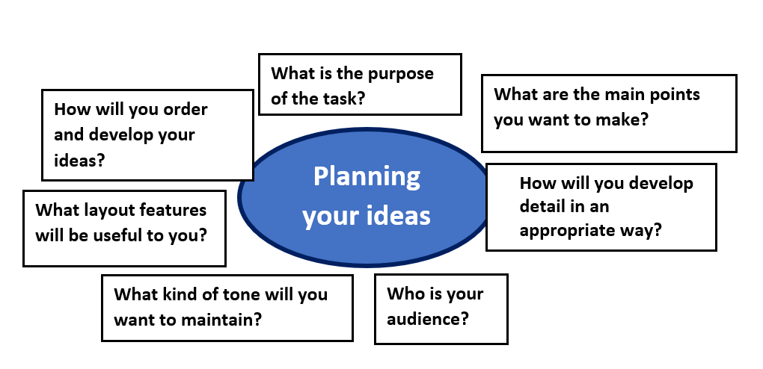
Structuring a report:
Think carefully about the structure of your report. The following features might help you to organise your writing:
- A brief title that makes clear the contents of your report.
- An introductory paragraph that clearly outlines what you will be writing about.
- Subheadings to help organise your writing.
- At least two or three main sections in which you include more details and ideas.
- A clear conclusion which addresses the task and contains your recommendations for what steps should be taken.

