
Next steps…

Work through the PowerPoint that accompanies this resource.

Read a range of different guides in your own time (for example a travel guide). Write down what works well. Are there any techniques that you can copy?

Work through some sample tasks and write a plan of what you might include.

Read your teacher’s feedback when you next write a guide. What do they think you need to do to improve?

Techniques for guide writing
A good guide is usually persuasive and encourages a reader to listen to the writer’s views, advice and opinions. It will usually be full of interesting details to encourage the reader to be guided to try out or avoid what you are writing about.
Think about:
- using strong opinions so the reader is clear about how you feel
- using persuasive techniques such as expert opinion to show the reader that you are well-informed
- including specific details such as the names of people, places or activities to make the reader feel that you are knowledgeable and should be listened to
- using inclusive/shared pronouns such as ‘we…our…us…’ make the reader feel the guide is a shared experience
Planning your content:
Before you begin, read the task carefully. It is really helpful if you plan out what you want to cover.
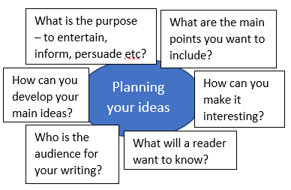

Structuring a guide:
1. Give your guide a title. Many students use the word ‘Guide’ in their title along with the topic that they are writing about.
2. Your opening paragraph should outline the topic and what you intend to include.
3. Write two or three main paragraphs including specific details and ideas with plenty of personal opinions and information.
4. Conclude your guide. Give any remaining details or opinions.

Definition:
A guide is a piece of writing found in a newspaper, magazine or other publication. It gives information about a topic as it guides a reader to learn more about it.
What is being tested?
- How you appeal to a reader, the quality of your ideas and how well you present them
- Your ability to use sentencing, grammar and vocabulary

Writing a guide– exam tasks:
2020
Write a lively guide to surviving the teenage years for a school/college magazine. [20]
Writing a guide– sample tasks:
Write an informative guide for new students who plan to join your school or college. [20]
Write a lively guide for visitors to your local area.

Write a guide for other GCSE students giving advice and information on how to survive their GCSE year. [20]

TOP TIPS:

- Start with a clear view of what your opinions are about the topic. Make these opinions constantly clear to a reader.
- When developing details, include as many details as you can so the reader feels like they have plenty of information.
- Do not be afraid to be honest, if you dislike the place you are writing about make it clear in your writing.
- Stay focused on the task.
- Give plenty of personal opinions.

Writing a guide

Examples of past synthesis questions:
The following questions all had the following introduction:
To answer the following questions, you must use both texts.
Using information from both texts, explain briefly in your own words what happened when news of the mining accidents became known. [4]
Using information from both texts, explain briefly in your own words what happened as a result of the volcanoes erupting in Anjer and Iceland. [4]
Using information from both texts, explain briefly in your own words, how the spectators reacted to Blondin and Wallenda. [4]
Using information from both texts, explain briefly in your own words how whales were hunted in 1850 and are now hunted in the Faroe Islands. [4]

Synthesising information

