
Techniques that you can use in your article:
A good article has the ability to engage the reader’s emotions. You might make them laugh, feel angry, sad or shocked or even persuade them to do something new.
Think about:
- effective words and phrases – use words that provoke emotions and feelings
- techniques such as rhetorical questions or imperatives - they make the reader pay attention to the points being made
- facts or statistics - they support what you are claiming and make the reader feel confident that you are knowledgeable
- pronouns such as ‘we…you…’ – these can make the reader feel the article is personal to them
- give options – including lots of different ideas will appeal to a range of readers
- anecdotes – short stories or messages to complement a point or message

Definition:
An article is a piece of writing found in a newspaper, magazine or other publication.
Planning your content:
Before you begin, read the task carefully. It is really helpful if you plan out what you want to cover.
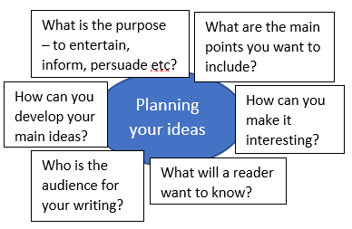

Structuring an article:
1. Give your article a title. Use something interesting or catchy if you are able to.
2. Start with a focused opening paragraph in which you outline the main idea or topic.
3. Include two or three main paragraphs in which you include more details and ideas.
4. Conclude your article. Either sum up your ideas or give the reader something thought provoking to think about.

What is being tested?
- How you appeal to a reader, the quality of your ideas and how well you present them
- Your ability to use sentencing, grammar and vocabulary

Next steps…

Work through the PowerPoint that accompanies this resource.

Read a range of different articles in your own time. Write down what works well. Are there any techniques that you can copy?

Work through some sample tasks and write a plan of what you might include.

Read your teacher’s feedback when you next write an article. What do they think you need to do to improve?

Writing an article – exam tasks:
Write a lively article for your school/college magazine with the heading:

A Teenager’s Guide to Managing Parents. [20]
A teenage magazine has invited readers to write articles on topics that people have strong views about. The latest topic is tattoos – are they harmless fun and fashion or something to regret in later life?

You decide to write an article on the topic for the teenage magazine, giving your views.

Write your article. [20]
A travel magazine is inviting readers to submit articles on places for a good day out for all the family. You decide to write about a place that you know well, where there is a lot to do for everyone in the family.

Write your article. [20]

TOP TIPS:

- Link ideas across paragraphs to create fluent writing – you might repeat ideas to reinforce a point.
- Do not use many bullet points. They do not allow you to show off your writing or punctuation skills.
- Use topic sentences at the start of paragraphs to help organise your work and introduce ideas.
- Keep checking the task you have been given to make sure you remain focused.
- Do not be afraid to use humour, where appropriate.

Writing an article

Examples of past synthesis questions:
The following questions all had the following introduction:
To answer the following questions, you must use both texts.
Using information from both texts, explain briefly in your own words what happened when news of the mining accidents became known. [4]
Using information from both texts, explain briefly in your own words what happened as a result of the volcanoes erupting in Anjer and Iceland. [4]
Using information from both texts, explain briefly in your own words, how the spectators reacted to Blondin and Wallenda. [4]
Using information from both texts, explain briefly in your own words how whales were hunted in 1850 and are now hunted in the Faroe Islands. [4]

Synthesising information

